National Fatherhood Initiative (NFI)
Fatherhood Programming Copy Blocks

For Use by
Organizations Applying for and/or Continuing with
Funding Related to Fatherhood Programs
Or Family Work which Includes Fathers

Table of Contents
ABout this document 3
ABOUT national Fatherhood Initiative (NFI) 4
NFI CONTACT INFORMATION 5
FATHERSOURCE™ skill-building RESOURCEs 6
FATHERSOLUTIONS™ TRAINING 13
FATHERServices™ technical assistance 14

About this Document

Applying for funding and/or planning for continued use of funding can be complex and time consuming. But with NFI’s help, you will be on your way toward creating a fatherhood program for your setting or enhancing the fatherhood program you already have. By incorporating NFI’s proven fatherhood curricula, resources, training and technical assistance into your application or continuing funding plan, your organization will be able to deliver a robust fatherhood program which will make a notable difference in the lives of the families you serve.

We encourage you to select resources for your fatherhood program in the way that best suits your organizational needs and setting – therefore, the copy blocks below are simply meant to be used as descriptive language to augment your fatherhood programming plan.

In addition, we advise you to modify the language once incorporated into your application or continuing funding plan to reflect the appropriate tone of voice for your submission (i.e. revising to “We will use the Doctor Dad® interactive workshop that empowers dads to become involved at the earliest stages of their child’s development …”, or “Our organization will run the 24/7 Dad® program which helps dads…” etc.)

Should you require additional information on NFI fatherhood programming products and/or training, please visit www.fathersource.org for more information.

NFI wishes your organization much success in your future fatherhood programming!

About National Fatherhood Initiative (NFI)

Creating a world in which every child has a 24/7 Dad.SM

NFI is the number one provider of fatherhood resources and training in the country, and is the most often quoted source on fatherhood by the media. Since it’s founding in 1994, NFI has provided national leadership on the issue of father absence, a root cause of many of our worst social problems. NFI’s mission is to improve the well being of children by increasing the proportion of children growing up with involved, responsible, and committed fathers. (NFI’s website, www.fatherhood.org, provides additional information on our organization, programming, and services.)

A non-partisan, non-sectarian organization, NFI has developed over 100 unique fatherhood resources available at www.fathersource.org (e.g. curricula, interactive CDs, brochures, and posters) and has distributed millions of these resources to fathers and organizations that work with dads, especially those working with low-income, non-custodial fathers.

In addition, NFI has trained more facilitators/practitioners, by a wide margin, than any other fatherhood organization in the U.S. We are here to help you plan and succeed with your fatherhood program and offerings. As the leader in training and technical assistance for organizations working with fathers, National Fatherhood Initiative has trained over 12,700 staff / facilitators in person, plus 12,000 via online webinar, from approximately 5,900 diverse organizations in all fifty states, Washington D.C., and other countries. Further, NFI has provided training on fatherhood curricula for federal (e.g. U.S. Dept. of Health and Human Services and Dept. of Justice), state (e.g. Ohio, Virginia, and Texas), and city government (e.g. Milwaukee and Pittsburgh) fatherhood initiatives/programs.

Lastly, NFI’s expert Programming Staff delivers fatherhood program facilitator training and Capacity Building workshops, along with Compression Planning, Father-Readiness Assessments, and Community Mobilization Planning services.

Valuable Research Supports your Proposal/Work: Father Facts™ 7 Downloadable Price: $49.99

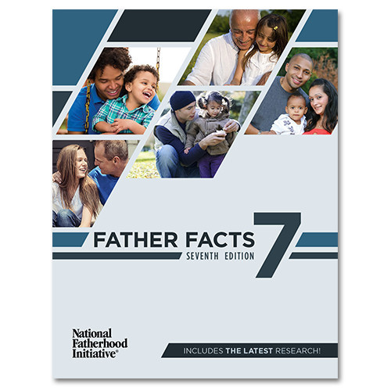
Complete with the latest statistics on family structure and father absence, Father Facts™ 7 is National Fatherhood Initiative’s comprehensive reference manual for organizations interested in promoting responsible fatherhood.
Father Facts™ 7 summarizes important research findings and trends concerning the negative consequences of father absence, the positive impact of father involvement, and the current demographics of American family structure. The report also allows you to pull out relevant statistics and charts for reference.

Father Facts™ 7 is also available in a printed version complete with a CD-ROM that makes data easy to search, and simple to use. For more information on Father Facts™ 6 or to order a copy, visit Father Facts 7.

Contact Information

For questions about National Fatherhood Initiative resources, training, events, and program implementation, please contact us via one of the contact methods below.

National Fatherhood Initiative
12410 Milestone Center Drive, Suite 600
Germantown, MD 20876
Phone: (301) 948-0599
Fax: (301) 948-6776
Email: programsupport@fatherhood.org
Web: www.fatherhood.org and www.fathersource.org

FatherSOURCE™: The Fatherhood Resource Center
FatherSOURCE™ offers unique products and services to help you connect with, and build the skills of fathers you serve. With over 100 products designed specifically for fathers, FatherSOURCE ™ resources can be found in pregnancy resource centers, correctional facilities, churches, community organizations and military bases all over the world.
__________________________________________________________

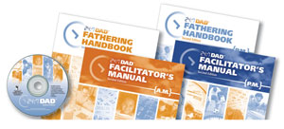
24/7 Dad® Complete Program Kit Price: $649

Background Information
Currently, one out of every three children in the U.S. now grows up without his or her biological father in the home – two out of three in African-American communities. Studies consistently show that kids who grow up without fathers in the home, on average, experience significantly worse outcomes than children from intact married homes. Given the harm caused by father absence and the benefits of father involvement, one of the most important things we can do to improve child well being is to increase the proportion of children growing up with involved, responsible, and committed fathers.

Resource Description
24/7 Dad® was developed by a team of nationally and internationally recognized fathering and parenting experts, and includes a basic fathering program (24/7 Dad® A.M.) as well as a more in-depth program (24/7 Dad® P.M.), each consisting of 12 two-hour sessions. 24/7 Dad® will soon have Spanish language handbooks available, making it simple to reach Spanish-speaking fathers in your community. 24/7 Dad® A.M. and 24/7 Dad® P.M. focus on five characteristics that a father needs to be a great dad 24 hours a day, 7 days a week. Both programs cover universal aspects of fatherhood so that men of all cultures, races, religions, and backgrounds can benefit from either program. When a father completes either program, he becomes a 24/7 Dad who:
- Is aware of himself as a man and aware of the significant impact he has in his family.
- Is a man who takes care of himself, and has a strong spiritual connection with his community, and chooses friends who reinforce his healthy choices.
- Is very aware of the significant role he has in the family, and capitalizes on his knowledge of the unique contributions he and his wife (or mother of his children) brings to raising their children.
- Is a nurturing parent who understands and accepts the importance his parenting skills have in developing the physical, emotional, intellectual, social, spiritual and creative needs of his children.
- Works to build and maintain healthy and supportive relationships with his children, wife, family, friends, and community.
24/7 Dad® includes a survey that allows facilitators to measure the progress of dads, after they complete the program, on a range of skills, attitudes, and knowledge related to involved, responsible, and committed fatherhood. NFI provides an answer key and a scoring worksheet that organizations (or an evaluator) can use to measure and report on outcomes.

For specific topics covered and sample excerpts from 24/7 Dad®, visit www.fatherhood.org/247dad. For program evaluations, visit www.fatherhood.org/247DadEvaluation.

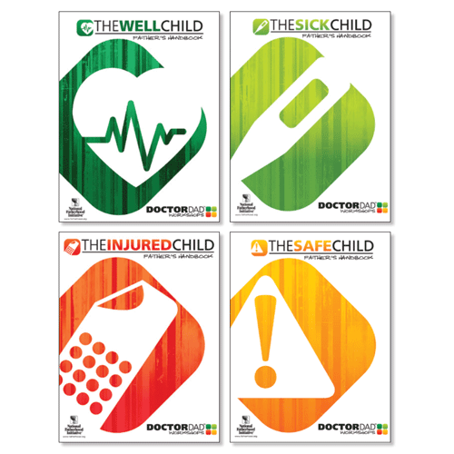
Doctor Dad® Complete Workshop Kit Price: $299
Background Information
Father involvement plays an important role in child and maternal health. Father involvement increases the likelihood that the mother will breastfeed and decreases the amount of accidents or injuries that infants and toddlers will experience. When fathers are involved, women are also less prone to post-partum depression. In addition, studies have demonstrated that father absence doubles the likelihood that the child will experience neglect and increases the probability that child abuse will take place.

Resource Description
Doctor Dad® offers 4 interactive one-day workshops that empower dads to become involved at the earliest stages of their child’s development by preparing them to handle basic health and safety issues with infants and toddlers. Accidents are the leading cause of death for children over the age of one in the U.S. today and children are 20 to 30% less likely to suffer from an injury when dads are involved. Doctor Dad® workshops specifically address these issues by including strong injury prevention and safety promotion components.

The four main components of Doctor Dad® are: the Well Child, the Sick Child, The Injured Child, and the Safe Child. Each component can be delivered as a stand-alone two-hour workshop, and perhaps most importantly, Doctor Dad® workshops help fathers see the indispensable contributions they can make to their child’s social, physical, emotional, and intellectual development.

Through skills and awareness learned from Doctor Dad® training, fathers develop the confidence that they can be successfully involved in their child’s life. Mothers gain greater confidence, too, that their partner is capable of caring for their children. And naturally, children are the greatest beneficiaries of their father’s increased parenting knowledge and greater understanding of the influence they exert in their children’s lives.

Doctor Dad® includes a survey allowing facilitators to measure the progress of the dads after they complete the programs on a range of skills, attitudes, and knowledge related to involved, responsible, and committed fatherhood. NFI provides an answer key that organizations (or an evaluator) can use to measure and report on outcomes.

For more information on the specific topics covered and sample excerpts from DoctorDad®, visit www.fatherhood.org/doctordad.

For DoctorDad® program evaluations, visit www.fatherhood.org/evaluation.

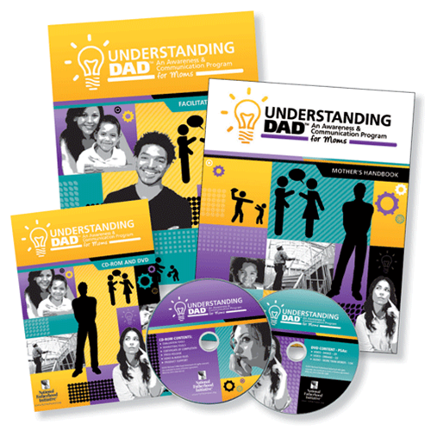
Understanding Dad™ Complete Program Kit Price: $549
Background Information
In 2012, NFI surveyed its customers and partners regarding the concept of a fatherhood organization creating resource for mothers to help them increase father involvement. With overwhelming support for creating these resources, we proceeded to create a program designed specifically for mothers, to help them improve the relationships they have with fathers, for the benefit of their children.

Data shows that one in three children in the U.S. grows up in a home without his or her biological father, and the lack of father involvement increases the risk that children will suffer from a range of social, emotional, and physical ills. Unfortunately, many times it's the mothers' gatekeeping behavior that can prevent or reduce fathers' access to their children - when fathers' involvement in their children's lives would actually benefit their children. In addition, mothers can lack the self-awareness and communications skills they need to improve their relationships with the fathers of their children.
Resource Description
Understanding Dad™ is a group-based program that helps moms focus on the goal of accomplishing communication and awareness objectives that are vital to improving the relationships between them and the father(s) of their children. The program covers topics to help moms gain a better understanding of their life as a mom, their father and mother’s impact, and their own impact on their children; then shifts to patterns of communication, open and safe communication, and how to listen.

Understanding Dad™ consists of 8 sessions, each lasting approximately 2 hours, with the goal of accomplishing 4 objectives that are vital to improving the relationships between mothers and fathers:
- Increase mothers’ knowledge, positive attitudes (e.g. toward fathers’ involvement), and skills (e.g. communication) associated with improving their relationships with the fathers of their children.
- Increase mothers’ awareness of the impact that their upbringing (e.g. their relationships with their own fathers) has had on their relationships with the fathers of their children and men in general.
- Increase mothers’ understanding of the importance of fathers’ involvement in the lives of their children.
- Increase positive interactions between mothers and the fathers of their children.

For more information on the specific topics covered and sample excerpts from Understanding Dad™, visit http://www.fatherhood.org/udad.

InsideOut Dad® Complete Program Kit Price: $599
Background Information
The role of father absence in the lives of prisoners and their children is well documented and sobering. Fathers in prison overwhelmingly are fatherless themselves, and many of their children will follow in their footsteps without successful intervention. Research has shown that children with incarcerated parents are far more likely to commit crimes than the children of non-incarcerated parents. In addition, research shows that ex-prisoners with strong family connections experience less recidivism and have better post-release employment histories.

InsideOut Dad® is in its Second edition, and is the nation's only evidence-based fatherhood program designed specifically for incarcerated fathers. Standardized programming for 25 states and many local corrections systems across the country (e.g. New York City), InsideOut Dad® helps reduce recidivism rates by reconnecting incarcerated fathers to their families, providing the motivation to get out and stay out. Popular among both inmates and ex-offenders, InsideOut Dad® has been proven to increase incarcerated fathers’ contact with their children and improve father’s knowledge and self-efficacy and to engender pro-fathering attitudes. Hundreds of local, state, and federal facilities, pre-release programs, community organizations, and more are using this life-changing reentry program.

Resource Description
InsideOut Dad® helps incarcerated fathers build strong ties with their children and understand what it means to be a good father. The program focuses on cognitive and attitudinal change and starts men on the path to becoming involved, responsible, and committed fathers, as well as better men overall. Most of these men will eventually be released, and acquiring the empathy and relational intelligence that the InsideOut Dad™ program fosters in fathers is an extremely important piece of their successful re-entry.

This comprehensive curriculum includes 12 core sessions and 4 optional reentry sessions that coordinate with the core topics, making it flexible for a variety of contexts! Through practical, engaging material, InsideOut Dad® increases inmates' self-worth and gives them valuable relationship skills.

InsideOut Dad® includes a survey that allows facilitators to measure the progress of the dads, after they complete the program, on a range of skills, attitudes, and knowledge related to involved, responsible, and committed fatherhood. NFI provides an answer key that organizations (or an evaluator) can use to measure and report on outcomes.

For more information on the specific topics covered and sample excerpts from InsideOut Dad®, visit http://www.fatherhood.org/iod.

For InsideOut Dad® program evaluations, visit www.fatherhood.org/evaluation.

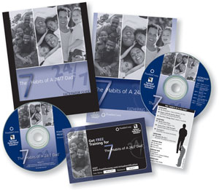
7 Habits of a 24/7 Dad™ Workshop Price: $379

7 Habits of A 24/7 Dad™ is an eight-hour workshop that combines the fundamental fathering principles from National Fatherhood Initiative’s 24/7 Dad® programs with FranklinCovey®’s timeless 7 Habits. This interactive workshop guides men as they adopt and apply seven helpful habits that will revolutionize their fathering skills and help them connect with their kids.
The 7 Habits of A 24/7 Dad™ is easy to implement and flexible for a wide-variety of programs, and can be used to launch a fatherhood program or as a complement to more in-depth fatherhood programming.

For more information and specific topics covered, visit www.fatherhood.org/7habits.

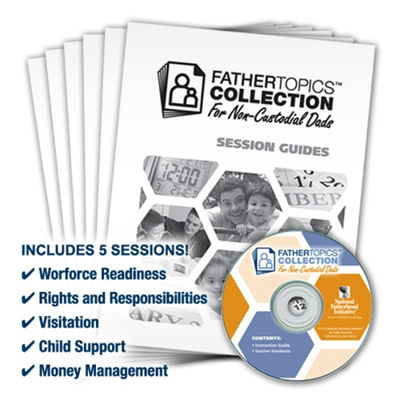
FatherTopics Collection for Non-Custodial Dads (Printed) Price: $159
Background Information
In 2011, the City of New York's Department of Youth and Community Development (DYCD) contracted with National Fatherhood Initiative (NFI) to create a version of 24/7 Dad® that organizations in the city would use with non-custodial fathers. The resulting DYCD version of 24/7 Dad® included new session content to provide information on some of the most critical issues faced by non-custodial fathers that don't directly address pro-fathering knowledge, attitudes, and skills.
Consequently, NFI decided to use that newly designed content to create FatherTopics™ Collection for Non-Custodial Dads, so that facilitators and organizations across the county could provide these well-received sessions to non-custodial fathers wherever they reside, and regardless of location. The reaction to these field-tested sessions, from facilitators and non-custodial fathers in New York City, has been overwhelmingly positive.
Resource Description
FatherTopics™ Collection for Non-Custodial Dads consists of five 2-hour sessions your organization can run as stand-alone workshops or as supplemental sessions to your fatherhood programming for non-custodial fathers to help them succeed as involved fathers. The Collection covers some of the most critical issues faced by non-custodial fathers:
- Workforce Readiness
- Rights & Responsibilities
- Visitation
- Child Support
- Money Management

Learn more at www.fatherhood.org/ft-collection.

FatherTopics™ Workshops (Downloadable) Price: $49.99 ea.
Please note: These workshops are only available for purchase as a downloadable product.

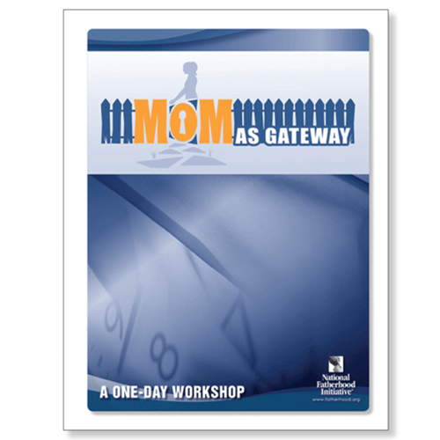
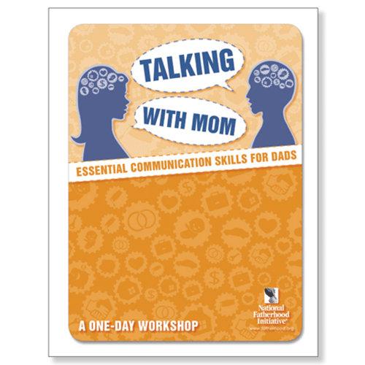
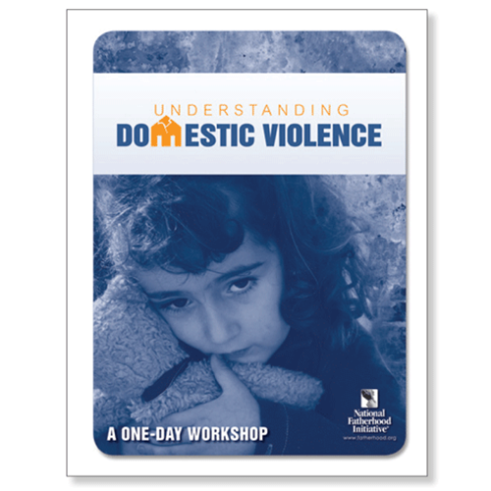
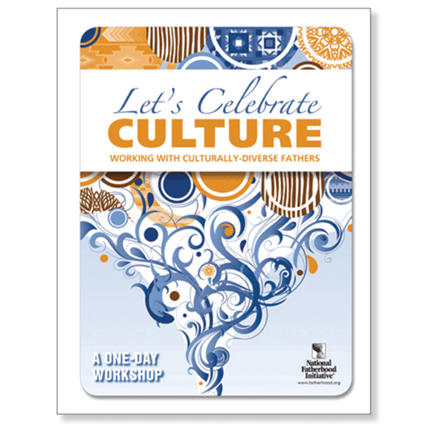
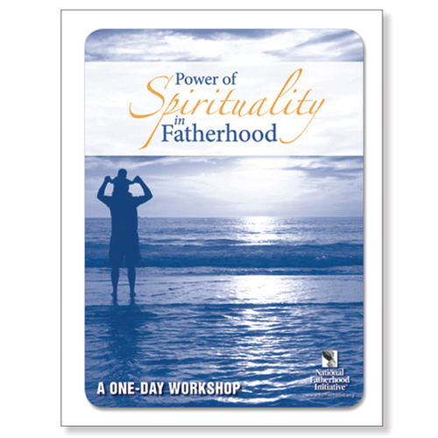
This series of downloadable workshop manuals allow you to run affordable, topical workshops for fathers on a variety of important issues that may be barriers to a father's involvement. Delivered in 3-4 hours as stand-alone workshops or as supplemental sessions to your fatherhood programming. Topics Available:
- Mom as Gateway™: This workshop helps you break down barriers between mothers and fathers by addressing what is known as Maternal Gatekeeping - when a mothers beliefs about a father, as well as her behaviors, hinder a father's involvement - and facilitate helpful discussions and efforts towards co-parenting.
- Talking with Mom™: The goal of this workshop is to help fathers become better communicators with the mother(s) of their children. This three-session workshop helps fathers become better communicators with the mother(s) of their children by learning about communication patterns, creating a safe environment for effective communication, and developing effective listening skills.
- Understanding Domestic Violence™: Fathers who participate in this workshop will increase their awareness of what domestic violence is and, as a result, reduce the likelihood of domestic violence in their families. This workshop has information on domestic violence, such as its cyclical nature and recognizing its red flags, which can help keep men out of a Batterer Intervention Program (BIP.)
- Let's Celebrate Culture™: This workshop helps fathers explore how their culture and cultural behaviors and beliefs influence their fathering and introduces several universal fathering skills, such as nurturing. This workshop is practical for working with fathers who are members of American subcultures (e.g. African American and Hispanic American) and who are members of subcultures that are not well acculturated or who are not acculturated at all (e.g. recent immigrants).
- Power of Spirituality in Fatherhood™: This workshop helps fathers consider spirituality as an other-centered or other-directed concept that strengthens or directs the power of faith in the importance of fathers, and in fathers capacity to be good - and even great - dads. Fathers must begin to see the well being of their children as more important than their own. This shift toward being other-centered is the tipping point that creates a cascade of changes in fathers.

For more information, visit http://www.fathersource.org.

Fatherhood Resource Kiosks + Price: Varies
Low-Intensity Skill-Building Resources
Resources such as brochures, posters, Dad’s and New Dad’s Pocket Guides™, Help Me Grow Guides™, and interactive CD-ROM products (such as 24/7 Dad® Interactive) are examples of low-intensity fatherhood skill-building resources, which require minimal staff time and monetary investment, while successfully providing life-changing, skill-building resources to fathers you serve.
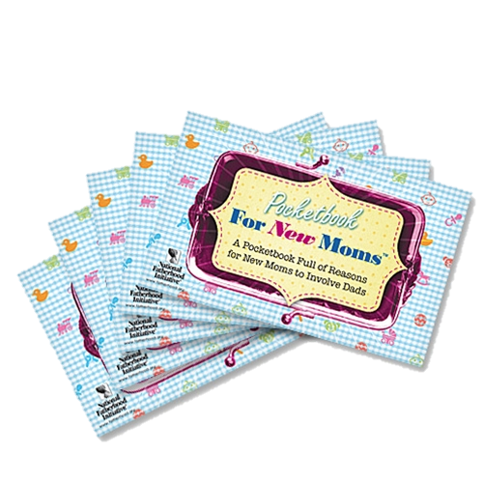
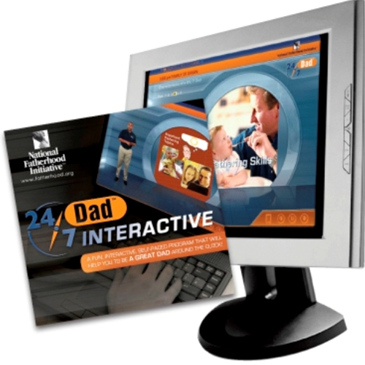
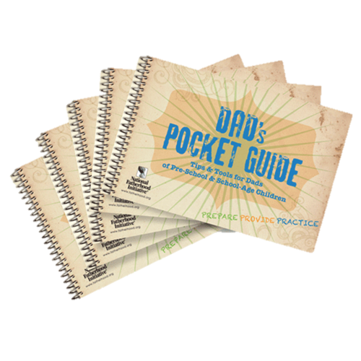
NFI also offers low-intensity resources for moms that help them understand the importance of father involvement, and to communicate with dad better. These include: Pocketbook for Moms on Communicating with Dad, Pocket for New Moms, and the Healthy Baby Tip Card for Moms.
Brochure titles include:
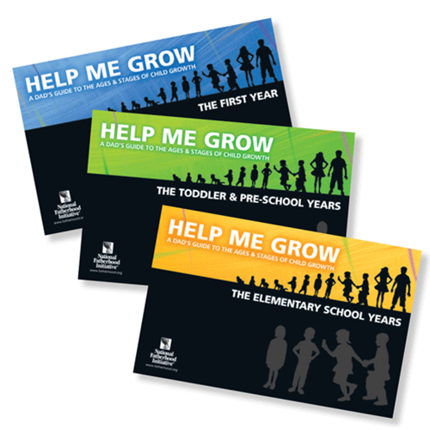
- 10 Ways To Be A Better Dad (Also in Tip Card)
- So You're A New Father (Also in Tip Card)
- How To Help Your Child Do Well In School (Also in Tip Card)
- Keeping Your Child Safe from Newborn To Toddler
- Staying Involved With Your Children While Incarcerated
- Creating a Reentry Plan
- 7 Benefits of Marriage for Men
- 10 Ways To Stay Involved With Your Children During Deployment
- Welcome Home Dad! Deployment Reunion Brochure
- How To Help Your Child Maintain a Healthy Weight
- How To Stay Healthy
- 12 Questions to Ask Before Becoming A Father
- Creating a Safe Home
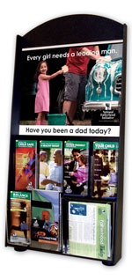
Fatherhood Resource Kiosks can be stocked with skill-building fatherhood brochures and tip cards that equip fathers on a variety of subjects related to being an involved, responsible and committed father.
Depending on the setting, kiosks are portable and placed in locations that are the most accessible for dads, such lobbies or waiting rooms.
For more info: http://www.fatherhood.org/FRC.

FatherSOLUTIONS™ Training
FatherSOLUTIONS™ provides your organization and partners with training opportunities to educate staff and to learn how best to facilitate our programs through Curriculum Training Institutes, implementing capacity-building solutions through our workshops, and increasing awareness through our Topical Presentations on Fatherhood.
__________________________________________________________
NFI Training Institutes Price: Varies
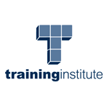
As the leader in training and technical assistance for organizations working with fathers, National Fatherhood Initiative has trained over 12,700 staff / facilitators in person, plus 12,000 via online webinar, from approximately 5,900 diverse organizations in all 50 states.
NFI offers 1 and 2 day train-the-facilitator Curricula Training Institutes that provide facilitators with an understanding of the core principles of the program, along with ideas and strategies for implementation. Plus, our interactive training institutes include both instructional and team-building exercises that give attendees a chance to practice facilitating the program. Participants will learn characteristics of a successful facilitator, program format and customization, how to evaluate their program, recruitment and retention and more! Trainings can be delivered one-on-one in our trainer's location or at the host's location for up to 30 attendees. Training on NFI’s curricula include:
- 24/7 Dad®
- Understanding Dad™
- InsideOut Dad®
- DoctorDad®
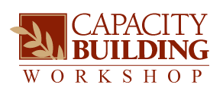
- 7 Habits of a 24/7 Dad™
NFI Capacity-Building Workshops Price: Varies
NFI also conducts 1/2, 1, and 2-day capacity-building workshops that provide solutions and best practices to help your fatherhood program succeed and thrive. These workshops are essential if you want to create new programs and services for dads or to enhance your existing work with dads. Workshops can be delivered one-on-one in our trainer's location or at the host's location for up to 30 attendees. Workshop topics include:
- Social Marketing for Fatherhood Programs™
- The 7 Bright Spots to Designing Your Fatherhood Program™
- Community Mobilization for Fatherhood Programs™
- Father Friendly Check-Up™
- Building Systems that Support Marriage in Fatherhood Programs™
- Engaging Non-Resident Fathers in Child Welfare Systems and Organizations™
- Engaging Fathers for Successful Reentry™

For more information on our Training Institutes and Workshops, visit www.fatherhood.org/training
or for a training quote, please email us at training@fatherhood.org.

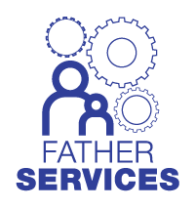
FatherSERVICES™ Technical Assistance from NFI
As the leader in training and technical assistance for organizations working with fathers, National Fatherhood Initiative has trained nearly 12,000 staff / facilitators in person, plus 10,000 via online webinar, from approximately 5,500 diverse organizations in all fifty states.
FatherSERVICES™ puts our professional staff at your fingertips - through customized technical assistance, program planning, and outreach services to help you engage NFI and your community!
Building a successful and sustainable fatherhood program is essential for the families and fathers you serve. NFI's technical assistance has helped organizations grow their programs and become more sustainable.
Research shows that NFI's Technical Assistance increases organizations' capacity to serve fathers by 20% or more and helps organizations sustain these programs and services over the long term. View the research: Inspiration to Implementation (June 2010) at https://www.fatherhood.org/www.fatherhood.org/Document.Doc?id=189
- Father-Readiness Assessment and Planning™:
NFI can help your agency and partners to create and implement a comprehensive, targeted plan to increase the readiness of an organization and its staff to engage fathers by:

- Conducting Father Friendly Check-Up™ (FFCU) workshops at the state, regional, or local levels.
- Working with your agency and/or partners to develop action plans using the latest online technology.
- This approach will allow you and your partners to process, track, and analyze assessment results quickly and easily.

- State, Regional, or Community Fatherhood Program Implementation:
NFI has the country’s most widely used fatherhood programs. Two independent studies show more federal grantees use NFI’s programs, by a wide margin, than any other program. Choose from 24/7 Dad®, InsideOut Dad®, Why Knot?™, or The 7 Habit of A 24/7 Dad™ and NFI can provide your entire state, region, or community with everything needed to roll out a successful, large-scale program.

- Fatherhood Program Camps:
These 2-day trainings combine your choice of the Father Friendly Check-Up™, Bright Spots™, or Social Marketing™ workshops on the first day with your choice of the 24/7 Dad®, InsideOut Dad®, Why Knot?™, or The 7 Habits of A 24/7 Dad™ Training Institutes on the 2nd day.

