National Fatherhood Initiative® (NFI)
Copy Blocks for NFI’s Core Programs, Training,
and Assessment Service

For Use by Organizations and Agencies
Applying for Funding

Table of Contents

About this Document ……………………………………………………………………………………………….. 3

24:7 Dad®…………………………………………………………………………………………………………………… 4

InsideOut Dad®…………………………………………………………………………………………………………… 8

Understanding Dad™ …………………………………………………………………………………………………. 11

ProFathering15™ ………………………………………………………………………………………………………. 14

Training ……………………………………………………………………………………………………………………… 16

Father-Readiness Network Assessment™……………………………………………………………………. 18

About National Fatherhood Initiative® ………………………………………………………………………. 19

Contact Information …………………………..………………………………………………………………………. 20

About this Document

Applying for funding can be complex and time-consuming. This document can help you save time when completing applications for grants and contracts that incorporate the core programs, training, and assessment service of National Fatherhood Initiative® (NFI). By incorporating NFI’s evidence-based and evidence-informed programs, training on implementing them, and our assessment service, your organization or agency will be able to deliver a robust fatherhood program—or otherwise include fathers in a larger family-focused program—that will make a notable difference in the lives of the families you serve.

This document includes descriptions—called “copy blocks” because of your ability to cut and paste all or portions of each description directly into an application—of the NFI resources that organizations and agencies most often include in applications for grants or contracts. These descriptions include answers to the most frequently asked questions we receive, such as:
- Can you provide a brief description of the program (or training or service)?
- How many sessions does the program include?
- How much does it cost to train facilitators?
- How many people will you train at one time?
- Has anyone evaluated the program? If so, what do evaluations show about its impact?
- How much does the program (or training or service) cost?

You can copy and paste content from any one or more of the copy blocks into your application as you see fit. Insert all or portions of the copy block(s). After you insert what you’d like to include, edit what you’ve inserted to reflect the appropriate tone for your submission.

Should you require additional information on these programs, training, or service—or any other NFI resources you’d like to include in your application—please visit www.fathersource.org for more information. If you need to speak with us, call us at 301-948-0599, and we’ll connect you with the most appropriate staff person to assist you.

Please note: All orders include FREE SHIPPING!

NFI wishes your organization or agency much success in acquiring funding for your work with fathers and families

24:7 Dad® A.M. and P.M., 4th Edition

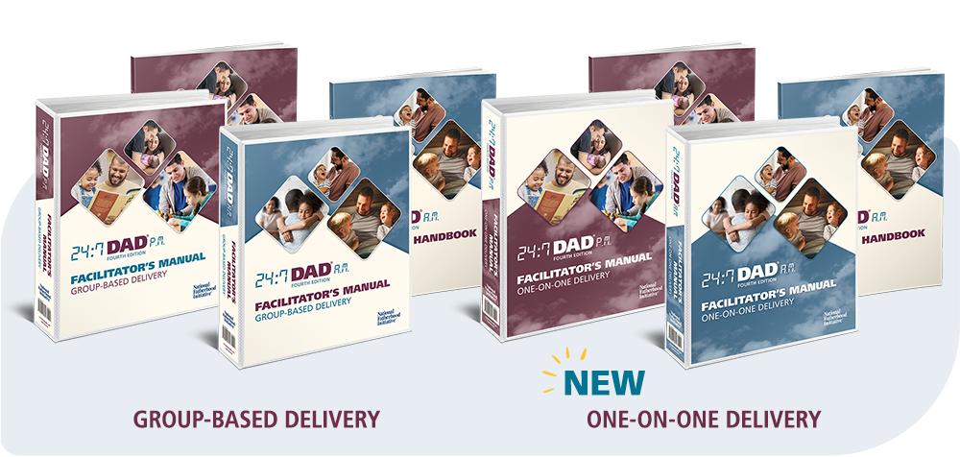
Program Description
24:7 Dad® is an evidence-based fatherhood program used by organizations nationwide to develop pro-fathering knowledge, attitudes, and skills of dads of all races, religions, and demographics. The program is built on the basis that fathers can be nurturers, and nurturing is a learned skill for men. Men examine their developmental history, learn the five characteristics of a 24:7 Dad®, and learn other important skills such as working with mom and proper child discipline to help them be the best dads they can be.

- 24:7 Dad® is available in two versions: 24:7 Dad® A.M. (covers foundational fathering skills) and 24:7 Dad® P.M. (covers advanced fathering skills). When organizations offer both, most begin with A.M. followed by P.M. However, you can offer P.M. first if that suits your organization better.
- New to the 4th edition, 24:7 Dad® offers two delivery options: group-based and one-on-one delivery (ideal for home visits or case management scenarios).

24:7 Dad® 4th Edition was enhanced using program evaluations, facilitator requests, and NFI staff’s observation of program facilitation. Enhancements include scripts for delivering content concisely, quickly, and powerfully, new inspiring videos of real dads, children, and families, even more sources supporting the program’s content, PowerPoint® slide decks, improved fathering surveys, and new tips and guidance on communication, healthy relationships, and more! See a list of what’s new here.

When a father completes either version, he becomes a 24:7 Dad who:
- Is aware of himself as a man and recognizes the significant impact he has on his family.
- Takes care of himself, maintains a strong spiritual connection with his community, and chooses friends who reinforce his healthy choices.
- Is very conscious of the vital role he plays in the family and capitalizes on his understanding of the unique contributions he and his wife/mother of his children/partner bring to raising their children.
- Is a nurturing parent who understands and values the importance of his parenting skills in developing the physical, emotional, intellectual, social, spiritual, and creative needs of his children.
- Works to build and maintain healthy and supportive relationships with his children, wife/mother of his children/partner, family, friends, and community.

24:7 Dad® includes a survey that allows facilitators to measure dads' progress after they complete the program on a range of skills, attitudes, and knowledge related to the program’s content. NFI provides an answer key and a scoring worksheet that organizations (or evaluators) can use to measure and report on outcomes.

Independent research shows that 24:7 Dad® creates statistically significant changes in pro-fathering knowledge, attitudes, and skills. (The program has undergone rigorous evaluations, including random assignment, by major universities.) It has been shown to build the five protective factors that research shows reduce the risk of child abuse and neglect, and to improve co-parenting. Click here to view all the program evaluations. To learn more about the program, including sample excerpts, click here.

Program Delivery
Delivered in a group setting by a facilitator(s) or in one-on-one case management and home visiting settings.

Number of Sessions
- 12 two-hour sessions in the A.M. program (plus an optional introductory session)
- 12 two-hour sessions in the P.M. program (plus an optional introductory session)

NFI also offers five booster sessions for non-custodial dads that can be used with 24:7 Dad® A.M. or P.M. For more information, click here.
24:7 Dad® A.M. Topics Covered:  Optional Introductory Session  - Family History  - What it Means to Be a Man  - Showing and Handling Feelings  - Men’s Health  - Communication  - The Father’s Role  - Disciplining Children  - Children’s Growth  - Getting Involved  - Working with Mom & Co-Parenting  - Dads and Work  - My 24:7 Dad® Checklist | 24:7 Dad® P.M. Topics Covered:  Optional Introductory Session  - Fathering and the 24:7 Dad  - Power and Control  - Boyhood to Manhood  - Competition and Fathering  - Dealing with Anger  - Improving my Communication Skills  - Knowing Myself  - Fun with the Kids  - Family Ties  - Stress, Alcohol, and Work  - Sex, Love, and Relationships  - My 24:7 Dad® Checklist

Program Delivery Requirements:
- Each Facilitator must acquire a 24:7 Dad® Facilitator’s Kit
- Each father participant must have a 24:7 Dad® Fathering Handbook (purchased separately)

Each Facilitator’s Kit Includes:
A robust collection of printed and downloadable support resources giving you the tools and confidence to run the program successfully and with fidelity.
- (1) 24:7 Dad® A.M. Facilitator's Manual with Program and Session Guides
- (1) 24:7 Dad® A.M. Fathering Handbook for facilitator reference
- Essential Program Support Resources via Download:
  - Customizable Press Release Template
  - Fidelity Guide and Fidelity Checklist
  - 16 videos that accompany the sessions
  - 24:7 Dad® Certificate of Completion (English and Spanish)
  - 24:7 Dad® Survey, Scoring Worksheet, and Scoring Instructions (English and Spanish)
  - 24:7 Dad® Reminder Cards and Pledge Cards (English and Spanish)
  - My 24:7 Dad® Checklist (English and Spanish)
  - Handouts specific to A.M. and P.M. (English and Spanish)
And that's not all—NFI is here to support your program with free technical assistance for as long as you run the program! 24:7 Dad® facilitators receive EXCLUSIVE access to:
- NFI's Facilitating Fatherhood Onboarding Support Series
- Quarterly Facilitator Support meetings
- Free technical assistance from NFI's Program Success Director and other NFI staff

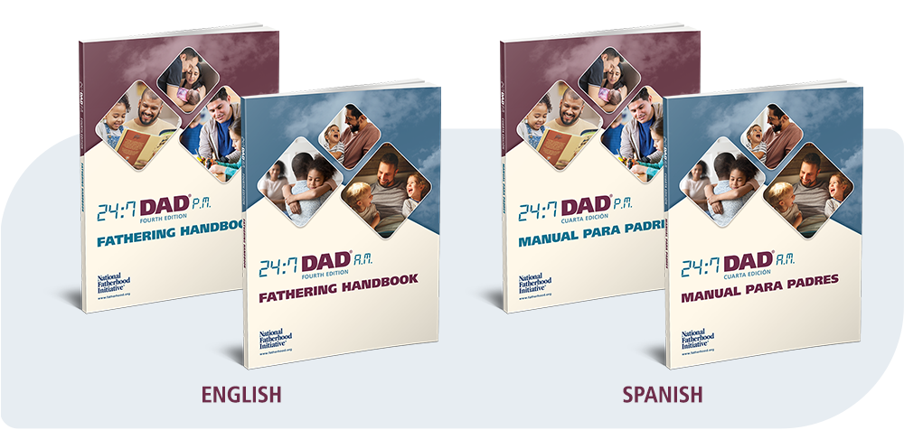
24:7 Dad® A.M. Fathering Handbooks Required (purchased separately):
The 24:7 Dad® A.M. and P.M. Fathering Handbooks are vital to facilitate dads’ learning and involvement in the program. They contain interactive and reflective activities and space for dads to write their answers or thoughts, enabling them to retain and reference this information long after the program concludes. Each book features two tear-out Quick Reference Cards: The Traits of the 24:7 Dad and 10 Praises for Your Children.

24:7 Dad® 4th Edition PRICE AND SKU LIST

GROUP-BASED DELIVERY
Version | Item | Delivery Method | SKU | Price
24:7 Dad® A.M. | English A.M. Facilitator’s Kit | Group-Based | 247AM4GB-KIT-EN | $899
24:7 Dad® A.M. | Spanish A.M. Facilitator’s Kit | Group-Based | 247AM4GB-KIT-SP | $899
24:7 Dad® A.M. | English A.M. Facilitator’s Kit with Non-Custodial Dads Booster Sessions | Group-Based | 247NC4-GBDL-AM | $1798
24:7 Dad® P.M. | English P.M. Facilitator’s Kit | Group-Based | 247PM4GB-KIT-EN | $899
24:7 Dad® P.M. | Spanish P.M. Facilitator’s Kit | Group-Based | 247PM4GB-KIT-SP | $899
24:7 Dad® P.M. | English P.M. Facilitator’s Kit with Non-Custodial Dads Booster Sessions | Group-Based | 247NC4-GBDL-PM | $1798
24:7 Dad® A.M. + P.M. – Save $250! | English A.M. + P.M. Facilitator’s Bundle | Group-Based | 247AP4-GBDL-EN | $1548
24:7 Dad® A.M. + P.M. – Save $250! | Spanish A.M. + P.M. Facilitator’s Bundle | Group-Based | 247AP4-GBDL-SP | $1548

ONE-ON-ONE DELIVERY
Version | Item | Delivery Method | SKU | Price
24:7 Dad® A.M. | English A.M. Facilitator’s Kit | One-On-One | 247AM4ONE-KIT-EN | $899
24:7 Dad® A.M. | Spanish A.M. Facilitator’s Kit | One-On-One | 247AM4ONE-KIT-SP | $899
24:7 Dad® P.M. | English P.M. Facilitator’s Kit | One-On-One | 247PM4ONE-KIT-EN | $899
24:7 Dad® P.M. | Spanish P.M. Facilitator’s Kit | One-On-One | 247PM4ONE-KIT-SP | $899
24:7 Dad® A.M. + P.M. – Save $250! | English A.M. + P.M. Facilitator’s Bundle | One-On-One | 247AP4-OBDL-EN | $1548
24:7 Dad® A.M. + P.M. – Save $250! | Spanish A.M. + P.M. Facilitator’s Bundle | One-On-One | 247AP4-OBDL-SP | $1548

FATHERING HANDBOOKS: SOLD SEPARATELY FROM KITS
Item | SKU | Price
24:7 Dad® 4th Ed. A.M. Fathering Handbook (English) | 247AM4-HBK-EN | $13.99 each
24:7 Dad® 4th Ed. A.M. Fathering Handbook (Spanish) | 247AM4-HBK-SP | $13.99 each
24:7 Dad® 4th Ed. P.M. Fathering Handbook (English) | 247PM4-HBK-EN | $13.99 each
24:7 Dad® 4th Ed. P.M. Fathering Handbook (Spanish) | 247PM4-HBK-SP | $13.99 each

24:7 Dad® Program Facilitator Training Options:
- On-demand individual training: $299 per person (training only.) Facilitator’s Kits are purchased separately. Learn more here.
- Custom 1 or 2-day training for your organization: via webinar ($3999/$6,999) or in-person ($9,999/$12,499) -training only. Facilitator’s Kits are purchased separately for each person trained. Request a quote here.
- Organizational Master Trainer (OMT) program: For more information and a quote, please contact Erik Vecere, Chief Partner Success Officer, at evecere@fatherhood.org.

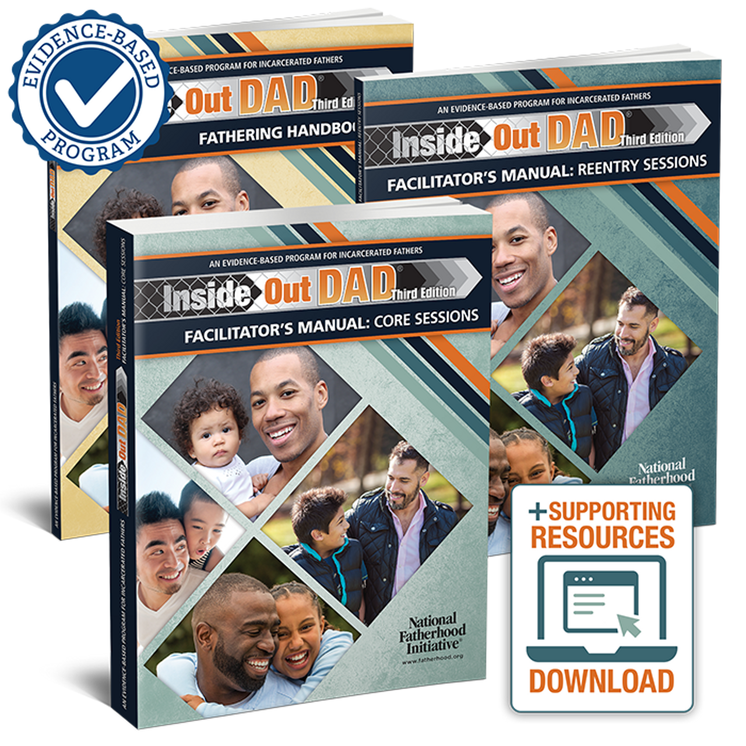
InsideOut Dad® 4th Edition
Program Description
Specifically developed for the challenges incarcerated fathers face, InsideOut Dad® is an evidence-based program that connects them to their children while they are in prison and prepares them for reentry when they leave. Research indicates that when inmates are connected to their families before release, they are less likely to return to prison.

Independent research has found that InsideOut Dad® increases fathers’ contact with children and develops pro-fathering knowledge, attitudes, and skills, and improves fathers’ well-being and co-parenting relationships. Hundreds of federal, state, and local corrections facilities—and transitional programs run by community-based organizations—use this life-changing program. Research has also found that the program can reduce recidivism rates when combined with other cognitive-behavioral interventions. Click here to view all of the program evaluations.

Program Delivery
Delivered in a group setting by a facilitator(s). You can also modify it for delivery in one-on-one case management.

Number of Sessions
InsideOut Dad® has 12 core sessions and 6 optional reentry sessions, each lasting approximately 2 hours. For more information on the program, including sample excerpts, visit http://www.fatherhood.org/iod.

Topics Covered
- Introduction
- Family History and the InsideOut Dad
- What It Means to Be a Man
- Showing and Handling Feelings
- Men’s Health
- Fathering from the Inside
- Communication
- The Father’s Role
- Children’s Growth
- Discipline
- Working with Mom and Co-Parenting
- Change and Impact

InsideOut Dad® optional reentry topics:
- Fathering on the Outside
- Responsibilities and Child Support
- Visits Upon Release
- Communication Patterns
- Safe Communication
- Money Management

Program Delivery Requirements:
- Each Facilitator must acquire an InsideOut Dad® Facilitator’s Kit
- Each father participant must have an InsideOut Dad® Fathering Handbook (purchased separately)

InsideOut Dad® Facilitator’s Kit
- $839 per Kit, Free Shipping
- SKU: IOD-KIT
Includes (Books bound for maximum security):
- 1 - InsideOut Dad® Core Sessions Manual: complete with information about the program’s underlying principles and themes and guided information for facilitating each session.
• 1 - InsideOut Dad® Reentry Sessions Manual: Optional use reentry sessions cover topics specific to challenges fathers may face upon reentry.
• 1 - InsideOut Dad® Fathering Handbook Fathering Handbook for Facilitator’s use
• Supporting Resources Download: includes Xavier’s Story Video, Handouts in English and Spanish, Optional Introductory Session, Certificate of Completion, Marketing Materials and much more!
- Facilitator Onboarding Email Support Series
- NFI-Hosted Quarterly Facilitator Support Meetings (Virtual)
- Ongoing free technical assistance from NFI Staff

InsideOut Dad® Fathering Handbooks Required (purchased separately); bound for maximum security:
- $11.99 per dad/handbook, free shipping
- SKUs: IOD-HBK-EN (English) and IODM-HBK-SP (Spanish)

Description: The InsideOut Dad® Fathering Handbooks are instrumental for dads’ learning and participation. Bound for maximum security.

Optional DVD featuring Xavier’s Story for use in facilities that cannot use the video download from the Support Resources web page. For use with a standard DVD player + TV setup.
$11.99 each
SKU: IOD-DVD

InsideOut Dad® Program Facilitator Training Options:
- On-demand individual training: $299 per person (training only.) Facilitator’s Kits are purchased separately. Learn more here.
- Custom 1 or 2-day training for your organization: via webinar ($3999/$6,999) or in-person ($9,999/$12,499) - training only. Facilitator’s Kits are purchased separately. Request a quote here.
- Organizational Master Trainer (OMT) program: For more information and a quote, please contact Erik Vecere, Chief Partner Success Officer, at evecere@fatherhood.org.

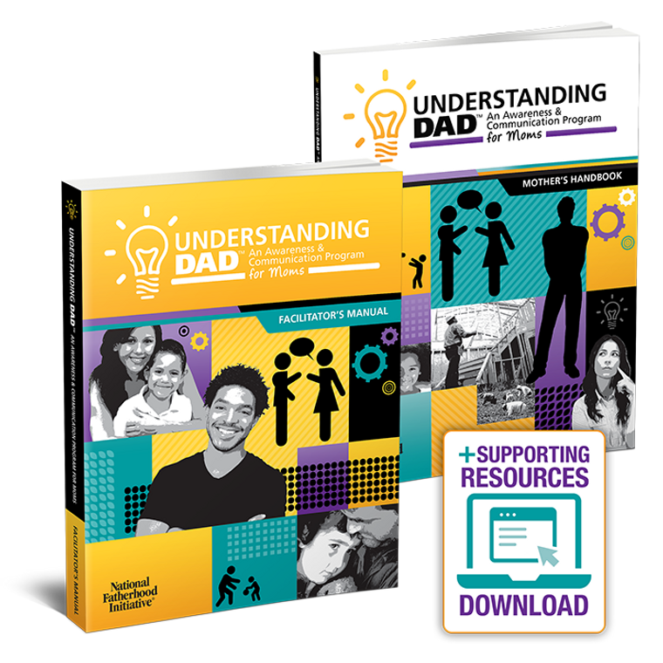
Understanding Dad™: An Awareness and Communication Program for Moms

Program Description
Understanding Dad™ is a group-based program that helps moms accomplish communication and awareness objectives vital to improving their relationships with their children’s father(s). The program covers topics to help moms better understand their life as a mom, their father and mother’s impact, and their impact on their children; then shifts to communication patterns, open and safe communication, and how to listen.

Researchers at Temple University (Philadelphia, PA) have evaluated the program. Their first evaluation found that mothers experienced significant gains in relationship awareness, knowledge of healthy co-parenting relationships, and relationship self-efficacy. In a second, more robust evaluation, they found increases in mothers’ co-parenting confidence and reduced disagreements between mothers and fathers. Click here to see all the program evaluations. For more information on the program, including sample excerpts, click here.

Program Delivery
Delivered in a group setting by a facilitator(s). You can also modify it for delivery in one-on-one case management and home visiting settings.

Number of Sessions
Understanding Dad™ consists of 8 sessions, each lasting approximately 2 hours, to accomplish four objectives that are vital to improving the relationships between mothers and fathers:
- Increase mothers’ knowledge, positive attitudes (e.g., toward fathers’ involvement), and skills (e.g., communication) associated with improving their relationships with their children's fathers.
- Increase mothers’ awareness of the impact that their upbringing (e.g., their relationships with their own fathers) has had on their relationships with the fathers of their children and men in general.
- Increase mothers’ understanding of the importance of fathers’ involvement in their children's lives.
- Increase positive interactions between mothers and the fathers of their children.

Topics Covered
- My Life as a Mom
- My Father's Impact
- My Mother's Impact
- Me and My Children's Father
- The Impact on My Children
- Patterns of Communication
- Open, Safe Communication
- How to Listen

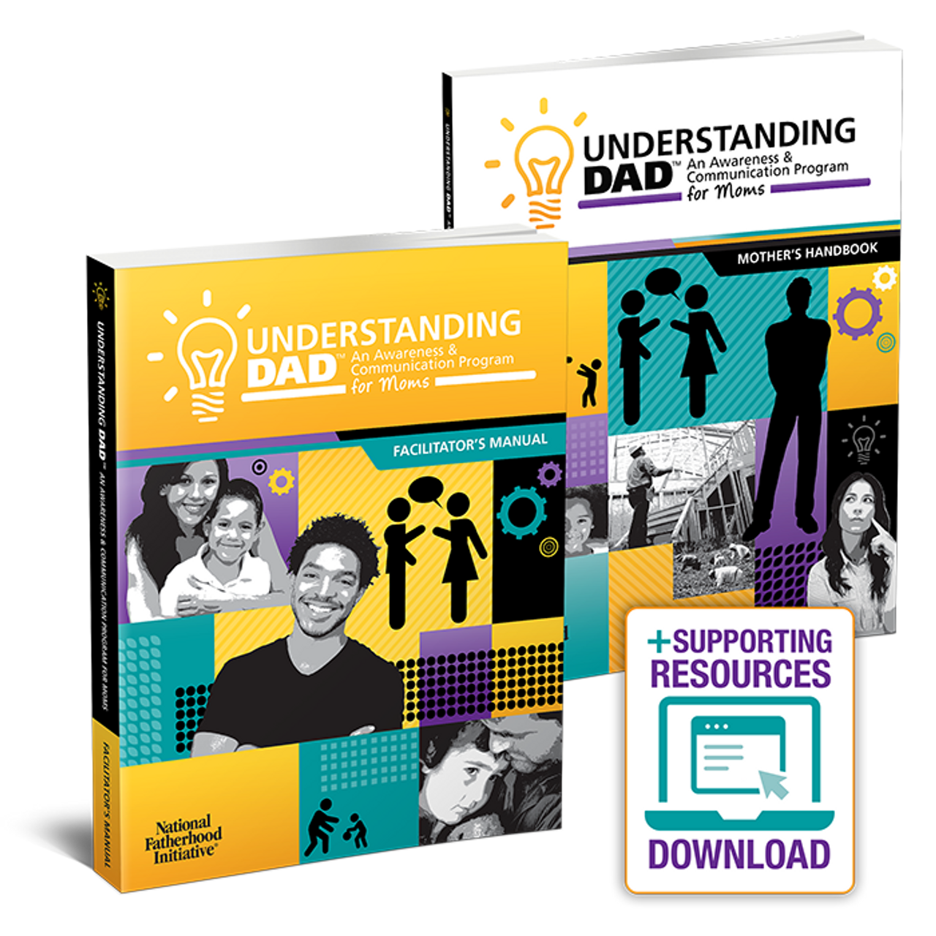
Understanding Dad™ Facilitator’s Kit:
- $659 per Kit, Free Shipping
- SKU: UD-KIT
Includes:
• 1 – Understanding Dad™ Facilitator’s Manual with Program Guide: in-depth instruction to easily facilitate the program. Facilitator Training is available but not required; see below for options and pricing.
• 1 – Understanding Dad™ Mother’s Handbook for Facilitator’s use
• Supporting Resources Download: Certificate of Completion, evaluation tools and worksheets, marketing resources, and more.
- Facilitator Onboarding Email Support Series
- NFI-Hosted Quarterly Facilitator Support Meetings (Virtual)
- Ongoing free technical assistance from NFI Staff

Understanding Dad Mother’s Handbooks Required (purchased separately):
- $11.99 per mom/handbook, free shipping
- SKUs: 247PM-HBK-EN (English) and 247PM-HBK-SP (Spanish)
Description: The Understanding Dad™ Mother’s Handbooks are instrumental for learning and participation.
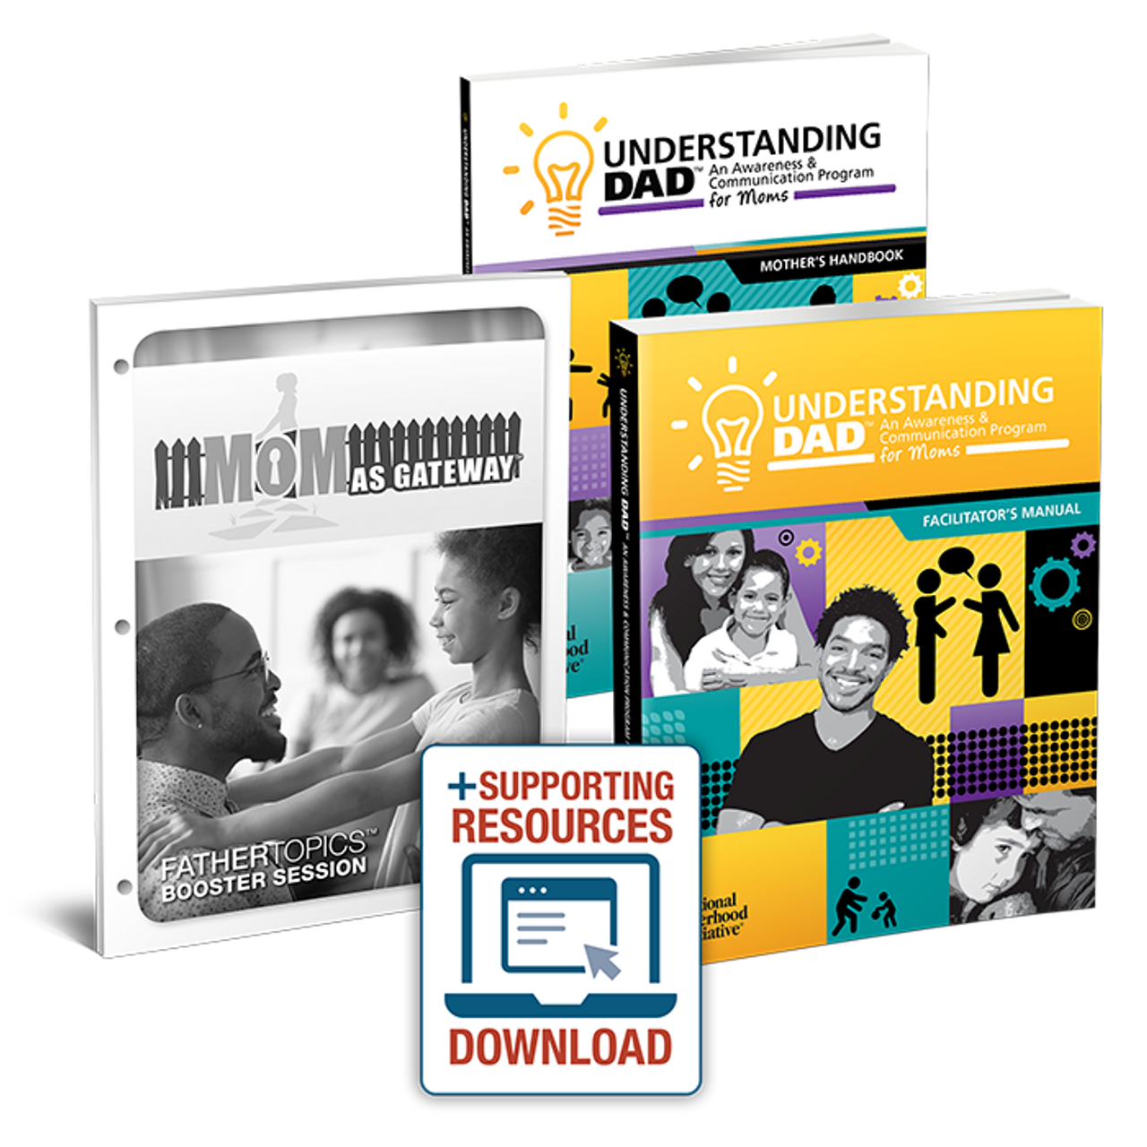
Understanding Dad™ with Mom as Gateway™ Booster Session
Use this bundle to create a powerful 12-session program for moms that addresses moms' gatekeeping behavior more comprehensively than either resource alone.
- Start with the optional introductory session in Understanding Dad™.
- Follow it with the eight core sessions of Understanding Dad™.
- End the program with the three sessions of Mom as Gateway™.
When moms go through Understanding Dad™ before Mom as Gateway™, it helps them to be more receptive to the latter resource's laser focus on their gatekeeping behavior. After the Understanding Dad™ program helps moms reflect on how their upbringing affects how they relate to dad, the importance of fathers to child well-being, and learn practical communication skills to help them more effectively interact with dad, they're more open to addressing their gatekeeping behavior head-on during Mom as Gateway™ sessions.

Additional topics covered with Mom as Gateway™:
- The Role of Mom as a Gatekeeper
- Power & Control in Relationships Between Men & Women
- Minimize Excessive Gatekeeping

The Understanding Dad™ with Mom as Gateway™ Booster Session Facilitator’s Kit
- Price: $719, free shipping
- SKU: UDMAG-BDL
Includes:
- 1 - Understanding Dad™ Facilitator's Manual
- 1 - Understanding Dad™ Mother’s Handbooks for facilitator’s use
- Support Resources Download includes an evaluation tool, marketing resources, and video content for some sessions.
- Facilitator Onboarding Email Support Series
- NFI-Hosted Quarterly Facilitator Support Meetings (Virtual)
- Ongoing free technical assistance from NFI Staff

Understanding Dad® Program Facilitator Training Options:
- On-demand individual training: $299 per person (training only.) Facilitator’s Kits are purchased separately. Learn more here.
- Custom 1 or 2-day training for your organization: via webinar ($3999/$6,999) or in-person ($9,999/$12,499) - training only. Facilitator’s Kits are purchased separately. Request a quote here.
- Organizational Master Trainer (OMT) program: For more information and a quote, please contact Erik Vecere, Chief Partner Success Officer, at evecere@fatherhood.org.

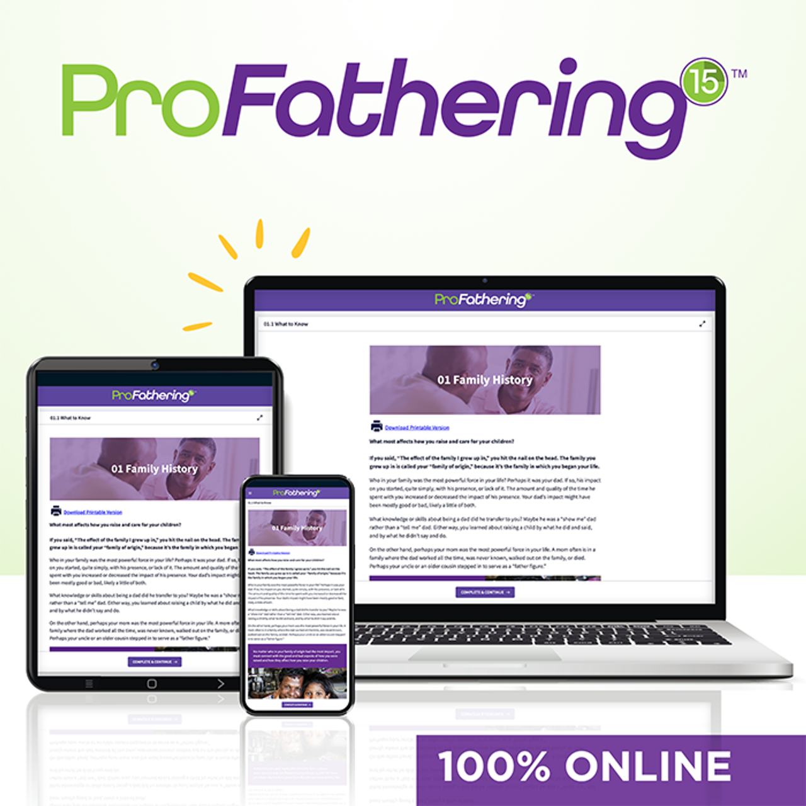
ProFathering15™

Program Description
ProFathering15™ is an interactive and engaging online program that focuses on building dads' skills in fathering, parenting, and healthy relationships.
Whether an expectant father, new dad, father of teenagers, custodial or noncustodial father, or father figure—ProFathering15™ builds the skills of any father with 15 important fatherhood topics relevant to any dad.
Related Resources
- View a preview of the program here
- Download the Program Guide here
- Download the Pre- and Post-Survey with Answer Sheet
How it Works
- ProFathering15™ is an online program for dads located here. You can enroll an individual dad or purchase enrollment credits to use with multiple dads. Credits are good for one year.
- Dads can go through the topics at their own pace, and each topic can be completed in only 15 minutes. A staff member could shadow the dad(s) and discuss the topics with him.
- Each topic combines important information to learn with an inspirational video followed by questions to ask, inspiring dads to be the best dads they can be.
- Once enrolled, dads have 60 days to complete the program. It can be stopped and started anytime, and their progress will be saved!
- Dads earn a certificate of completion once all topics have been completed in the online learning system.

Benefits and Features:
- Builds pro-fathering knowledge, attitudes, and skills
- Draws on content from NFI’s evidence-informed and evidence-based programs
- Eases recruitment and retention challenges: 15 topics take just 15 minutes each to complete
- Easy to read: 5th-6th grade reading level
- Flexible: Use as self-paced, in one-on-one work with dads, or as a supplement to a group-based program
- Convenient: Dads and staff can access it on any computer, tablet, or smartphone

Program Delivery: Fathers access ProFathering15™ on any computer or mobile device.

Number of Sessions: 15 sessions that can each be completed in approximately 15 minutes.

Topics Covered:
- Family History
- Being a Man and Dad
- Handling Emotions
- Grief and Loss
- Your Health
- You and Mom
- Talking with Mom
- Co-Parenting
- Fathering Skills
- Child Development
- Child Discipline
- Sexuality
- Intimacy
- Work-Family Balance
- Managing Money

Pricing
$15 per dad. Purchase enrollment credits for multiple dads and use them over 1 year. SKU: PF15-01
Learn more about ProFathering15™ here.

Training Overview for NFI Programs
NFI offers a variety of in-person and online training on how to run and facilitate NFI’s core programs and that educate staff on how to effectively engage fathers, recruit fathers, and facilitate a program regardless of the program used by an organization or agency.

Core Program Facilitator Training
NFI delivers training on our core fatherhood programs in two ways:
- For individuals via on-demand training courses
- For groups via custom webinar or in person at the organization location
Core program training provides facilitators with an understanding of the program's core principles, along with ideas and strategies for implementation. On-demand training is easy and convenient and allows you to train staff anytime, anywhere, and on your timeline.
NFI’s live training institutes can include instructional and team-building exercises that allow attendees to practice facilitating the program. Participants learn about the objectives of the program, its components, structure, and format; how to implement the program with fidelity or to customize it to meet the needs of your organization; how to evaluate the program; how to recruit and retain participants, and more.
Training Cost for Core Programs: Facilitator’s Kits are purchased separately for all training.
- Individual on-demand core program training: $299 per person (training only). See details here.
- Public Webinar Training (24:7 Dad® only): $299 per person (training only). See the schedule here.
- Customized Webinar Training: 1-Day $3,999 | 2-Day $6,999 (training only).
- Customized In-Person Training for up to 30 people: 1-Day $9,999 | 2-Day: $12,499 (training only).

To request a training quote, please visit https://www.fatherhood.org/training-institute.

Train Staff in Father Engagement, Recruitment, and Facilitation with NFI’s Certificates
NFI also offers online, on-demand training in a certificate format for fatherhood practioners and program facilitators that enhance their ability to run and faciliate any fatherhood program or other father-serving effort effectively. An individual staff member can earn any one or more of these certificates. To include them in a funding application, simply multiply the cost of the certificate(s) by the number of staff who will complete the training. Receiving certificates from the nation’s leader in fatherhood lends credibility to staff that you include in an application (e.g., project staff).

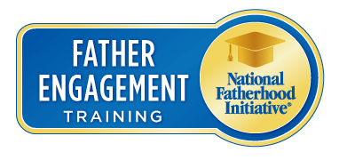
The Father Engagement Certificate™
This online, on-demand training course covers the five core competencies for effective father engagement in any organization, setting, or community, regardless of the kinds of fathers served.
$249 per person.

Topics Covered:

- Foundational: How to Create a Father-Friendly Organization.
- Program Design: 7 Best Practices in Designing a Fatherhood Program.
- Recruitment & Retention: How to Think Like a Marketer When Marketing a Fatherhood Program.
- Involving Moms: How to Work with Moms to Encourage Father Involvement.
- Fundraising: How to Develop a Funding Plan for a Fatherhood Program.
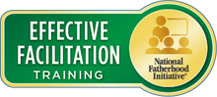
The Effective Facilitation Certificate™
This online, on-demand training course covers the characteristics and skills of an excellent fatherhood program facilitator, adult learning styles that affect how program participants learn and engage, how to properly prepare to facilitate every session, and more. It costs $249 per person.

Topics Covered:
- Part 1 > The Facilitator: Characteristics and Skills
- Part 2 > The Participants (Fathers): Learning Styles, Autonomy, Mastery and Purpose, and Cognitive Biases
- Part 3 > Facilitation: Your Role, Preparation, and Techniques
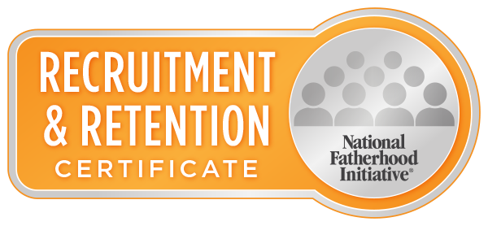
The Recruitment and Retention Certificate™
This online, on-demand training course covers developing a successful plan to recruit and retain fathers in any fatherhood program or other father-serving effort. $249 per person.

Topics Covered:
- The proper mindset to address this all-too-common pain point among family service providers.
- The "Build-Measure-Assess-Refine" loop: the process for developing a successful recruitment and retention plan.
- The foundation you must put in place to succeed with recruitment and retention, and how to build on that foundation by adding customized recruitment and retention tactics.
- Examples of NFI partners' success with recruitment and retention that you can use.

To learn more about our certificate training, visit https://www.fatherhoodpractitioners.org/collections/certificates.

The Father-Readiness Network Assessment™

NFI partners with organizations and agencies to reach their father engagement goals by helping them assess their and their partners (e.g., grantees and community-based organizations) readiness to engage fathers. We deliver a report on the results of an assessment and follow-up training on how to implement, based on assessment results, customized action plans to improve father engagement at scale (e.g., across a community, region, state, or the entire country).

The Father-Readiness Network Assessment™ is a comprehensive assessment that helps measure your network's level of father engagement at micro and/or macro levels. It is great for any national, state, or local private or public organization or agency (e.g., government) with multiple sites, offices, or partners (e.g., grantees)—a network—and that wants to improve the level of father engagement.

To conduct the assessment, NFI manages the deployment of an online version of its copyrighted, trademarked Father Friendly Check-Up™ (FFCU) to assess:
- How well each site/office engages fathers in programs and services
- Whether the culture of each site/office is well suited for effectively engaging fathers.

The FFCU consists of four parts or “assessment categories”:
- Leadership Development: The attitudes, beliefs, and values held by the organization’s employees—the culture of the organization—and its impact on the delivery of services and programs.
- Organizational Development: The “nuts and bolts” of an organization that carries out its mission through organizational capacity as reflected in areas such as 1) policies and procedures, 2) processes, and 3) physical environment.
- Program Development: The services and programs an organization offers, how it engages staff in offering them, and how it promotes and markets them.
- Community Engagement: The ability of an organization to engage its community in delivering services and programs.

The assessment is completed by your staff/partners and results in a comprehensive, customized report. A total numeric score can be given for each assessment category for each site/office and/or the entire network, thus creating a clear picture of how father friendly each site/office is specifically and the entire network is generally. NFI can "slice" the data (e.g. by state, region, county, type of site/office, etc.) to give a snapshot of your network's level of father friendliness and lay the foundation for an effective tactical plan to engage fathers.

The assessment results form the foundation on which each site/office and/or the entire network can build a tactical plan to increase father engagement and, as a result, increase father involvement in the families you serve generally. Each site/office can implement its own plan, or you can implement a single plan for all of the sites/offices.

Details and Pricing
The Father-Readiness Network Assessment™ costs $14,999 for up to 30 sites/offices. You can add extra sites for an additional, affordable cost.

To learn more, click here.

About National Fatherhood Initiative® (NFI)

National Fatherhood Initiative® was founded in 1994 to reverse our nation’s destructive trend toward father
absence. Today, 18.4 million American children live in homes without a biological, step, or adoptive father. On
average, these children face a host of risks to their physical, economic, social, and emotional well-being as a
result of living without the presence of an involved, responsible, and committed father. Therefore, NFI’s
mission is to increase father involvement by equipping human service organizations and communities with the
father-engagement training, programs, and resources they need to be father-inclusive. Accordingly, we
accomplish our mission by:
- Educating and inspiring organizations and communities about the importance of fathers through social media, earned media, research, and free resources.
- Equipping organizations and communities with fatherhood programs and resources, training, planning, and technical assistance services.
- Engaging and assisting organizations and communities to mobilize at the micro- and macro-level to increase father involvement in children's lives.

Since its founding, NFI has distributed more than 11 million resources to fathers, organizations, and
communities.

Capacity-Building at the Organization Level

NFI builds the capacity of community-based, corrections, and military organizations seeking to begin or

enhance fatherhood programs to benefit fathers, families, and especially children in their communities. Our

services build capacity through father-friendly assessments, skills training, technical assistance, strategic

planning, and community mobilization around fatherhood. Specifically:
- NFI is the nation’s #1 trainer of organizations and staff on how to engage fathers in their children's lives effectively. Since 2002 and through the third quarter of the fiscal year 2024, NFI has trained 44,933 staff from 10,091 organizations on delivering our fatherhood programs. NFI’s evidence-based 24:7 Dad® program is the country's most widely used fathering program among community-based organizations.
- NFI is the nation’s #1 provider of fatherhood programs and resources for incarcerated fathers. Half of the nation’s state departments of corrections choose NFI’s evidence-based InsideOut Dad® program as their standard fathering program across all facilities for men.
- NFI is the nation’s #1 provider of fatherhood programs and resources for military fathers. NFI’s programs and resources are used in every military branch (on U.S. and abroad installations), by many Reserves and most National Guard units. We have distributed our programs and resources to
installations in all 50 states, U.S. territories, and many other countries (e.g., Japan, Turkey, Okinawa, Germany, Portugal, Spain, Korea, and the Netherlands).

Capacity Building at the State and Local Government Levels

NFI has extensive experience executing state and local government contracts, subcontracts, and projects

related to building and implementing sustainable fatherhood programs and services in a high-quality manner.

NFI works with state and local agencies and programs to build their capacity in father engagement and the

capacity of their grantees and partners.
Valuable Research Supports Your Proposal and Work: Father Facts™ 9
Packed with the most comprehensive data and research available on the benefits of father involvement and the negative impacts of father absence, Father Facts™ is the ultimate reference manual for anyone passionate about promoting father involvement and advocating for father-inclusive initiatives.

Father Facts™ 9 uses a strengths-based framework that emphasizes research on the benefits of involved fathers. With over 370 new entries and 21 new chapters and sections compared to the previous edition, Father Facts™ 9 encompasses a broader range of international studies and more descriptive data, particularly on the various types and categories of fathers.

Topics Covered: Click here to view the Table of Contents.
Price: $99; click here to purchase.

Common Uses by Human Service Organizations
- Provide general support (evidence) for your organization’s work with fathers.
- Advocate for father-inclusive efforts within your organization, collaborative, or coalition.
- Include data and research in grant proposals.
- Raise staff awareness and knowledge about the importance of fathers.
- Use for professional development/growth (your own and fellow staff).
- Raise community awareness about the importance of fathers. h
- Share with the media to generate free press/PR for your organization’s father-inclusive efforts.
- Use in presentations for any audience.

Contact Information

National Fatherhood Initiative®
PO Box 37635, PMB 84123
Philadelphia, Pennsylvania 19101-0635
Phone: (301) 948-0599
Email: info@fatherhood.org
Web: www.fatherhood.org and www.fathersource.org

